**Understanding your emotions and maintaining positive mental health.**

**Workbook for Students**



**How are you feeling?**

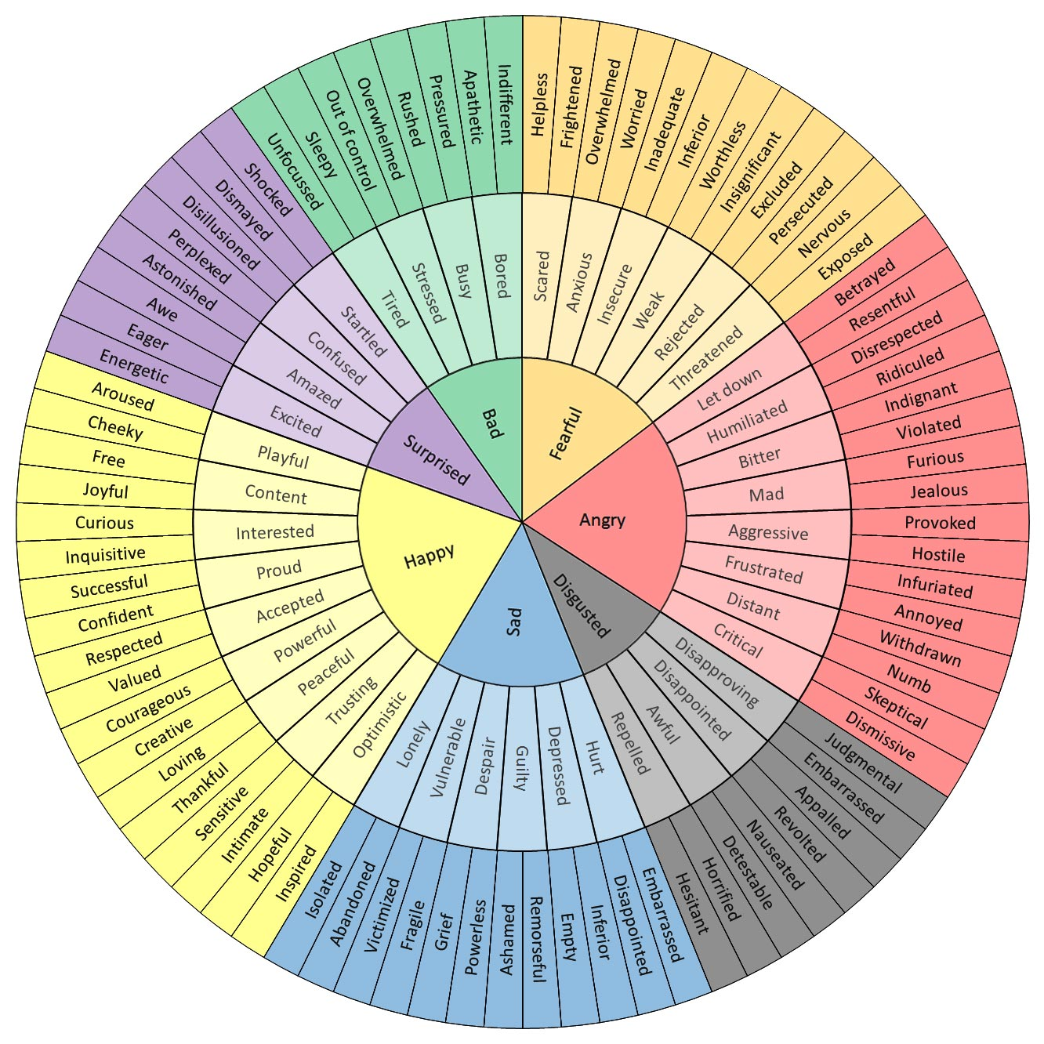

**Emotional Intensity**

Our emotions are not always the same level of intensity. We experience some things mildly and they can then build until we feel overwhelmed and out of control.

It might help to think of your emotional intensity like a boiling pot. It starts of simmering, then starts to boil, then boils over.

**Use your feelings wheel (and any other emotion words you think of) to fill out the table below. Decide whether you think the emotion is mild, medium or intense. Try and place as many emotion words as you can.**

|  |  |  |  |  |
| --- | --- | --- | --- | --- |
|  | **Fear** | **Anger** | **Sadness** | **Happiness** |
| **Mild** | worried |  |  |  |
| **Medium** | anxious |  |  |  |
|  | terrified |  |  |  |

**What’s the message?**

**Our emotions act like a messenger – telling us that something important is happening around us or to us that we need to pay attention to.**

**Each emotion has its own message and can be triggered by many different scenarios, and each comes with advantages and disadvantages**

|  |  |  |  |  |
| --- | --- | --- | --- | --- |
| **Emotion** | **Message** | **Possible Cause** | **Advantage** | **Disadvantage** |
| **Fear** |  |  |  |  |
| **Anger** |  |  |  |  |
| **Sadness** |  |  |  |  |
| **Guilt** |  |  |  |  |
| **Happiness** |  |  |  |  |

**Healthy coping skills – TIPP**

The TIPP technique can be used in times of intense emotions when things feel overwhelming.

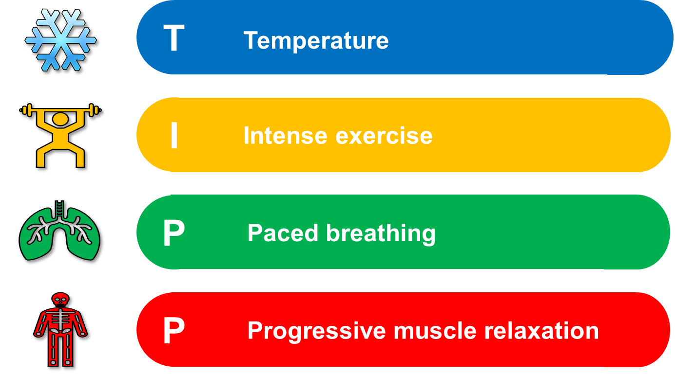

### T - Temperature

All mammals possess something called a ‘*dive reflex’,* which is activated when we put cold water on our faces or submerge ourselves in cold water.

The reflex tells our body to slow our heart to below its resting heart rate.

It does so by activating our parasympathetic nervous system, which is responsible for our *‘rest and digest’* functions.

This can be done in a variety of ways.

* You could dip your face in a bowl of cold water for 5 seconds
* Splash cold water on your face
* Sit in a comfortable spot and place cold ice or gel packs on your face
* Cover your face with a cold washcloth.

However, the effects of this skill are short-lived.

Be sure to use another skill to help calm yourself down further - once you are able to.

### I – Intense Exercise

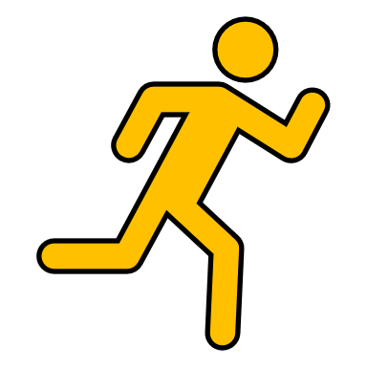Often when we feel intense emotions, we also feel an intense urge to act. This is often because our fight/flight response has been triggered and our body has responded by getting us ‘ready for action’. Sometimes our urges tell us to *‘do’* something negative.

Intense exercise helps soothe the body’s urge to *‘do something now!’*.

It also has mood-boosting benefits, both during and after the physical activity.

After exercise, our parasympathetic nervous system is activated again, naturally bringing our heart rate and respirations to a more manageable level.

Even if it’s just jumping up and down for 30 seconds, it can be very effective at taking some intensity out of emotions and also release some nervous energy.

You could try:

* Running up and down stairs
* Running on the spot
* Star jumps
* Using a punchbag (or pillow!)

***P – Paced Breathing***

Slowing your breathing down, and just the act of concentrating on your breathing for a few minutes, can help reduce the intensity of your emotions. This skill can be done anywhere and no one else will know you are doing it either!

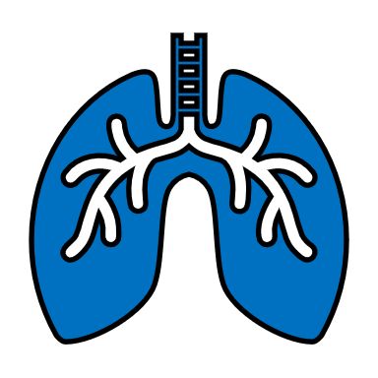Try the following technique:

1. **Breathe** in deeply through your nose (*abdominal breathing*) for **5 seconds**
2. **Hold** for **5 seconds**
3. **Breathe out** through your mouth for**7 seconds**.
4. **Repeat** - Do this for several minutes.
5. **Stop** when your breathing is calmer

The aim is to **slow** your breaths, making your out-breath longer than your in-breath.

Practice by placing a hand on your stomach or chest to make sure that you are breathing in as fully and as deeply as you possibly can.

This skill needs to be done for several minutes to be most effective.

### SkeletonP – Progressive Muscle Relaxation

Refocusing your mind onto various muscle groups throughout the body provides an excellent distraction from racing thoughts.

The goal here is awareness of body tension. Allow yourself fifteen minutes for this exercise.

Begin with your toes:

* Scrunch up your toes as hard as you can
* Hold the tension for 5 seconds
* Quickly relax the muscles completely – you can exhale and shake out that area of the body if that helps
* Wait 10 seconds before moving on to the next muscle group.

Continue by working your way slowly up your body, so after the toes, switch to the muscles around your ankles and lower leg, then your knees, then thighs etc, all the way up to your face and head. Don’t forget your hands!

**Healthy coping skills – Mindfulness**

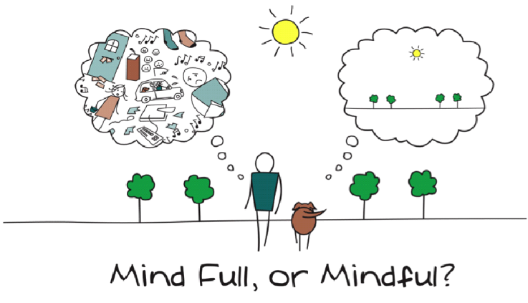

* **Mindfulness** helps you focus on one thing at a time in the present moment, and by doing this you can better control and soothe your overwhelming emotions.
* **Mindfulness** can help to relax our body by activating our parasympathetic nervous system, encouraging our bodies to transition into a state of relaxed awareness.
* **Mindfulness** can help you to learn to identify judgemental thoughts.

**Observe Describe One Mind Fully**

Thoughts Thoughts One thing at a time

Emotions Sensations Whole focus on task

Environment Observations Re-focus if needed

Use your 5 senses Don’t judge!

Don’t judge!

**Examples of things that can be done mind-fully**

|  |  |
| --- | --- |
| Colouring | Gardening |
| Exercise – no music! | Taking a bath or shower |
| Eating and drinking | Brushing teeth (try with your ‘other’ hand!) |
| Cooking | Holding/interacting with a pet |
| Drawing/art/sculpting | Observing an everyday object |
| Walking – no phone or music! | Breathing |
| Being in nature | Exploring sensory/fidget toys |

**Monday**

**What feelings have featured in your day?**

**What are you letting go of today?** today?

**What are you grateful for today?**

**One of today’s challenges (big or small)**

**One of today’s triumph’s (big or small)**

**One thing you learned from your triumph or challenge**

**Draw a giraffe**

**54321…**

What **5** things can you **see** right now?

**Tuesday**

**What feelings have featured in your day?**

**What are you letting go of today?** today?

**What are you grateful for today?**

**One of today’s challenges (big or small)**

**One of today’s triumph’s (big or small)**

**One thing you learned from your triumph or challenge**

**Draw a tree**

**54321 …**

What **4** things can you **hear** right now?

**Wednesday**

**What feelings have featured in your day?**

**What are you letting go of today?** today?

**What are you grateful for today?**

**One of today’s challenges (big or small)**

**One of today’s triumph’s (big or small)**

**One thing you learned from your triumph or challenge**

**Draw a bird**

**54321…**

What **3** things can you **touch** right now?

**Thursday**

**What feelings have featured in your day?**

**What are you letting go of today?** today?

**What are you grateful for today?**

**One of today’s challenges (big or small)**

**One of today’s triumph’s (big or small)**

**One thing you learned from your triumph or challenge**

**Draw a cow**

**54321…**

What **2** things can you **smell** right now?

**Friday**

**What feelings have featured in your day?**

**What are you letting go of today?** today?

**What are you grateful for today?**

**One of today’s challenges (big or small)**

**One of today’s triumph’s (big or small)**

**One thing you learned from your triumph or challenge**

**Draw an alien**

**54321…**

What **1** thing can you **taste** right now?

**Saturday**

**What feelings have featured in your day?**

**What are you letting go of today?** today?

**What are you grateful for today?**

**One of today’s challenges (big or small)**

**One of today’s triumph’s (big or small)**

**One thing you learned from your triumph or challenge**

**Draw a flower**

**All the circles…**

How many things can you see around you that are circular?

**Sunday**

**What feelings have featured in your day?**

**What are you letting go of today?** today?

**What are you grateful for today?**

**One of today’s challenges (big or small)**

**One of today’s triumph’s (big or small)**

**One thing you learned from your triumph or challenge**

**Draw an elephant**

**All the squares…**

How many things can you see around you that are square?

**Healthy coping skills – Challenging Negative Thoughts**

When we are faced with a challenging situation, we have an emotional reaction to it.

This reaction is often accompanied by certain thought processes which are often unhelpful, and distressing and they increase our emotional suffering *(a vicious cycle).*

**Event** leads to **thinking error** which affects your **emotions**

**OR**

**Event**



**Thoughts**



**Emotions**

**Event**



**Emotions**



**Thoughts**

**Common Thought Distortions (Thinking Errors)**

|  |  |  |
| --- | --- | --- |
|  | **Tunnel Vision** | You pick out the negative details in any situation and dwell on them exclusively, filtering out any positive or neutral details. You conclude that the whole situation is negative. **Example:** You get a test back from school, with 5 out of 100 questions marked wrong, and you focus only on the 5 wrong, ignoring the 95 questions you answered correctly. |
|  | **Reject the positive** | You ignore evidence that challenges your negative attitude, often finding quick and clever ways to discount any positive information. You reject positive experiences by insisting they *“don’t count”* for some reason or other. **Example:** Someone compliments you on your appearance. You immediately reject the statement by saying the person has poor taste. |
|  | **Over generalisation** | You come to a general conclusion based on a single incident or piece of evidence. You believe that if a negative event happens once, it will always happen, again and again. Frequently involves use of the words “always” or “never.” **Example:** You ask someone out for a date and the person turns you down. You conclude that no one will ever want to go out with you. |
|  | **Jumping to conclusions** | You jump to a negative conclusion that is not supported by the facts or situation. **Example ‘Mind Reading’:** You believe you know what someone else is thinking about you and you react accordingly, without checking what they are ACTUALLY thinking. |
|  | **Catastrophising** | Believing there will always be a negative outcome of any situation, and deciding that if this outcome happens, it will be a disaster. This often involves exaggerating the effect of something negative. **Example:** ‘I’m going to fail my exams and then I won’t get into University and then I won’t be able to pursue the career I want. And even if I pass the exam, I won’t get the grade I need to get into my first choice of Uni. And even if I get into Uni, I will fail my degree. And even if I get my degree, no one will offer me a job. But I’d be rubbish at it anyway!’ |
|  | **Fortune telling/self-fulfilling prophecy** | Believing something awful will happen and then acting or reacting as if it already has, therefore causing the situation to come about. **Example:** ‘I’m not going to get the part in the play so there’s no point in auditioning.’ So you don’t audition and don’t get the part in the play. |
|  | **Labelling** | Attaching a negative label to yourself or others and then viewing yourself/them in a negative light from then on **Example:** ‘I’m a loser’, ‘he’s a liar’ |
|  | **Should/must statements** | You have an ironclad list of rules about how things should be, especially how you and others should act. When you or others don’t meet these high expectations, you feel guilty and critical towards yourself or pass judgement and become resentful towards others. Look out for thoughts that include ‘should’ and ‘must’. **Example:** You believe that people should always be on time no matter what. A friend is a few minutes late to meet you. You judge her harshly and act ‘off’ with her. You are not interested in reasons beyond her control for why she is late and you don’t forgive her. |
|  | **Personalisation/Bias** | You think that if something has gone wrong it’s your fault, or it’s always about you. **Example:** Your friend is unusually quiet and you assume they are upset with you for something, or a teacher calls you over to speak to you and you assume you are in trouble. |
|  | **Fallacy of fairness** | You believe life should always be completely fair and get very angry and upset when it is not. **Example:** You submit a picture for an art contest. You don’t win and feel upset and angry and think that you should have been equally rewarded because you put in a lot of effort. |
|  | **Bias** | You come up with a negative explanation for the actions of others. **Example:** Someone bumps into you are lunchtime causing you to drop your drink. You conclude they did it on purpose to humiliate you. |
|  | **Minimising/Selectiveness** | You minimise or ignore information that does not fit with how you view yourself or your situation. You focus only on one piece of information (usually negative) and ignore the rest. Example: You play a musical instrument and play six pieces of music. You make a small mistake in one piece. Afterwards, your music teachers complements your playing in all the pieces, and notes the small error as something to work on for next time. You respond with ‘why do you only point out my faults?’ |
|  | **Fallacy of control** | You believe that you should be able to always control your environment and situations and when that doesn’t happen you get very distressed. Example: You burn a meal you are cooking because you are also busy trying to clean your room and finish your homework. You believe you should be able to multitask in this way and that you are a failure for not being able to do so on this occasion. |
|  | **Black and White thinking** | Things are all or nothing. Everything is all good or all bad, right or wrong, perfect of totally failure. In reality, there is always a middle ground. Look out for words like ‘always, never, everything, everyone’. Example: You make a spelling mistake in your work ‘I wanted it to be perfect, now it’s totally ruined, I always fail at everything. I never get anything right.’ |
|  | **Blaming** | You blame yourself for things that are not your responsibility, or you blame others for everything and never accept responsibility yourself. **Example blaming others:** You forget to complete your homework and blame your mum for not reminding you. **Example blaming yourself:** Your wallet is stolen from your bag and you blame yourself for it’s loss. |
|  | **Superstitious thinking** | Illogical cause and effect **Example:** if something good happens then that means something bad is going to happen next. |

Thoughts are not facts. They can and should be tested and challenged if they are causing us distress, or causing us to view ourselves or others in a negative way.

**What is your negative thought?**

**Examine the** **EVIDENCE**



* Am I confusing a fact with an opinion? Is it the opinion of someone else?

______________________________________________________________________

* What is the evidence for the negative thought?

______________________________________________________________________

______________________________________________________________________

______________________________________________________________________

* What is the evidence against the negative thought?

______________________________________________________________________

______________________________________________________________________

______________________________________________________________________

* Are there any small things that contradict the thought? Perhaps things I am discounting as unimportant?

______________________________________________________________________

______________________________________________________________________

______________________________________________________________________

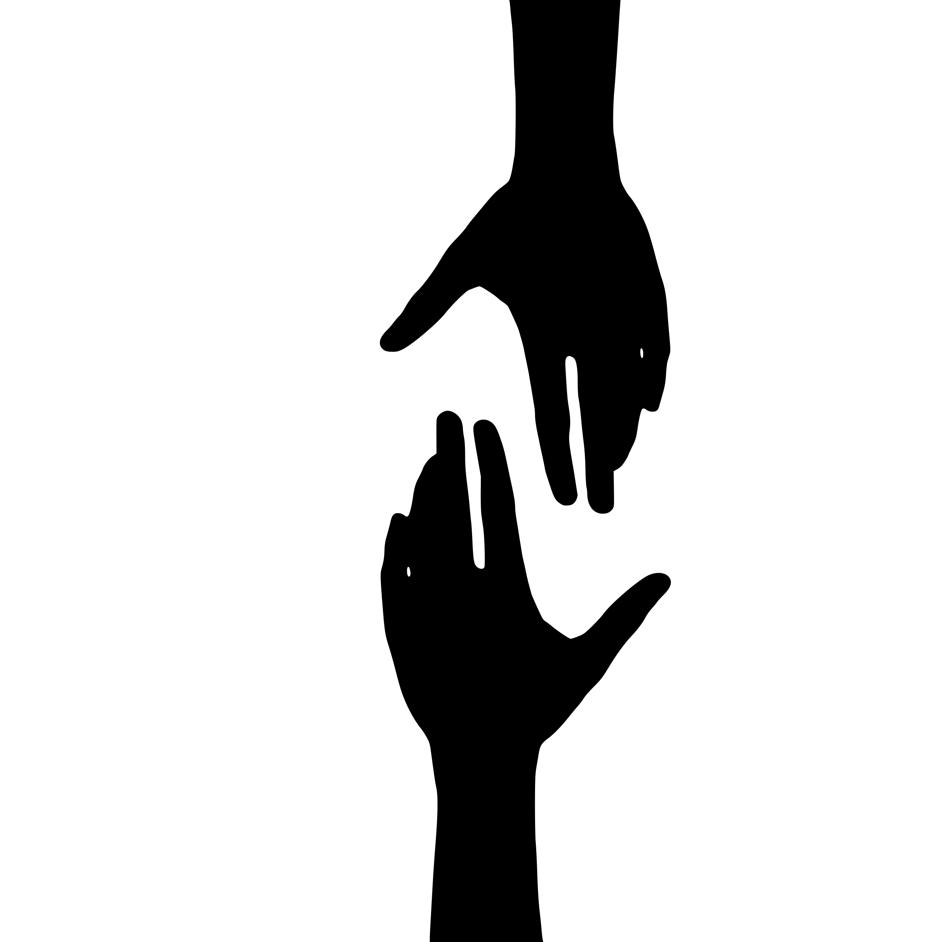

**Question the** **HELPFULNESS**

* Are these thoughts helpful to me? YES / NO
* Will thoughts like this help me to achieve my goals? YES / NO
* Do thoughts like this truly have my best interest at heart? YES / NO

**Explore** **ALTERNATIVE PERSPECTIVES**

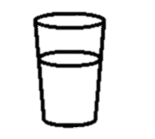

Empty



Full

* If my friend knew I was having this thought, what would they say to me? (Try asking!)

______________________________________________________________________

______________________________________________________________________

* If someone I loved had this thought, what would I tell them?

______________________________________________________________________

______________________________________________________________________

* What would batman say to me about this thought?

______________________________________________________________________

______________________________________________________________________

* Am I making the mistake of assuming my perspective on this issue is the only one?

______________________________________________________________________

______________________________________________________________________

* Ten years from now, if I look back on this situation, will I look at it any differently?

______________________________________________________________________

______________________________________________________________________

* If this was happening to someone else how would I view the situation?

______________________________________________________________________

______________________________________________________________________



**Uncover BIAS**

* Am I thinking in all-or-nothing terms? YES / NO / MAYBE

(Am I using words like ‘always’ or ‘never’?)

* Am I catastrophizing? YES / NO / MAYBE
* Am I jumping to conclusions or making assumptions YES / NO / MAYBE that are not justified by the evidence?
* Am I holding myself to a higher standard than I would YES / NO / MAYBE hold other people?
* Am I labelling myself? YES / NO / MAYBE
* Am I focussing on my weaknesses and minimising my strengths? YES / NO / MAYBE
* Am I making unreasonable demands? YES / NO / MAYBE

(Am I using words like ‘should’ or ‘must’?)

* Am I blaming myself for something over which I have no control? YES / NO / MAYBE

**Look back over all your answers, then write a new statement to challenge the original thought.**

**Healthy coping skills – Grounding**

Grounding acts a bit like pressing a ‘reset’ button for your brain. Grounding techniques distract you from the situation you are in, or the emotions that are causing you distress, and refocus your attention on what’s happening in the present moment.

Grounding techniques often use the five senses — *sound, touch, smell, taste, and sight* — to immediately connect you with the here and now.

**Create your own Soothing Box**

Sensory items and objects refocus your attention, grounding and relaxing you to manage your emotions.

You could include:

* Sensory items – Something to smell, touch, look at and/or taste
* Something to trigger positive memories
* Little notes or cards from friends and family that make you feel good
* A favourite food or drink item (non-perishable!)

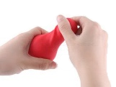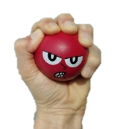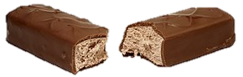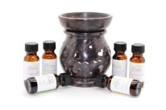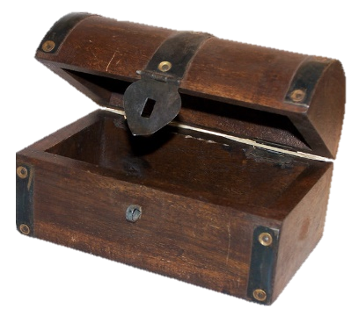

**Things to put in my soothing box:**

**_____________________ ___________________**

**_____________________ ___________________**

**_____________________ ___________________**

**_____________________ ___________________**

**_____________________ ___________________**

**_____________________ ___________________**

**_____________________ ___________________**

**_____________________ ___________________**

**Healthy coping skills – Prompt Card**

When you are feeling distressed or very emotional it can be hard to remember what to do that is helpful. A prompt card can act as a reminder of what you can do to manage.

You can also share the prompt card with other people, such as family members, or teachers, so they know how to help you if you are distressed.

**My Emotional Wellbeing Prompt Card**

**Healthy coping skills – PLEASE Skills**

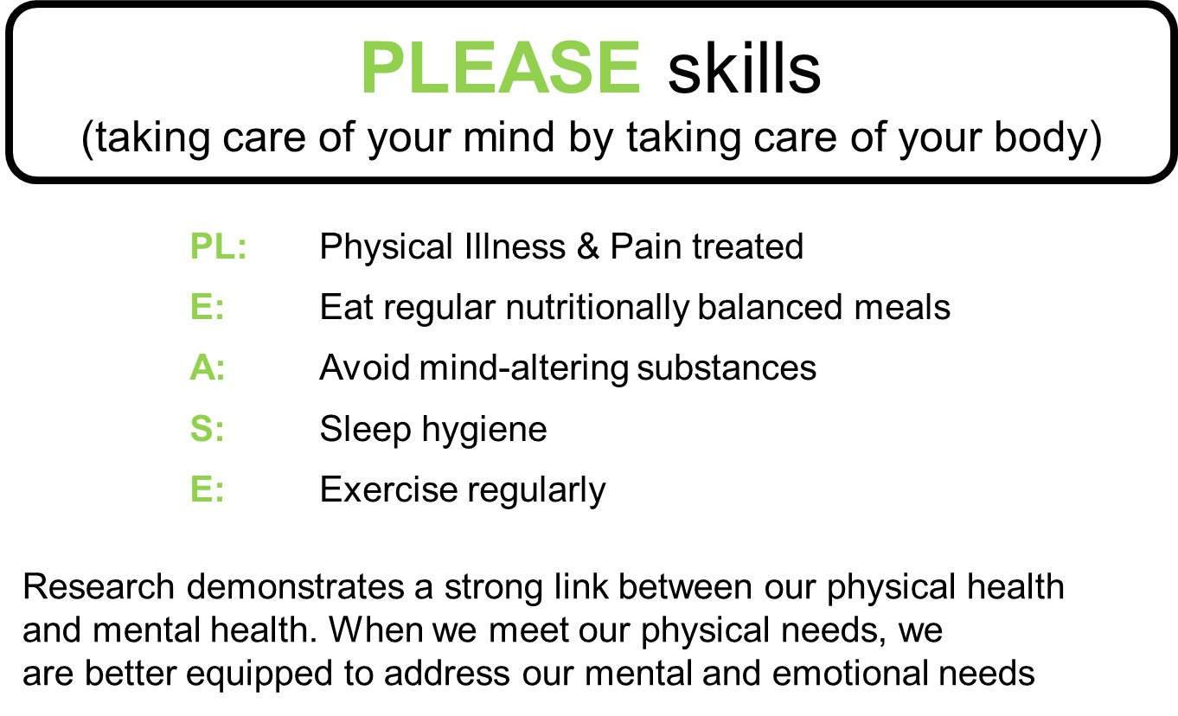

|  |  |
| --- | --- |
| **Area** | **Ways I can meet this need** |
| **PL:** |  |
| **E:** |  |
| **A:** |  |
| **S:** |  |
| **E:** |  |

**How full is your Stress Bucket?**

